January 2019 Adult Programs
Sunday  12-5 PM | Monday  10-9 PM | Tuesday  10-9 PM | Wednesday  10-9 PM | Thursday  10-9 PM | Friday  10-5 PM | Saturday  10-5 PM
All ages all month long  Winter Coloring Craze  and  Puzzlemania! |  | 1  CLOSED | 2  7:30 – 8:45 pm  Book Club: The Underground Railroad by Colson Whitehead | 3 | 4 | 5  10 am – 12 noon  Beginner Knitters
6 | 7  7 – 8:30 pm  Painted Cactus Rocks | 8  7 – 8 pm  Drop-in Tech Help | 9  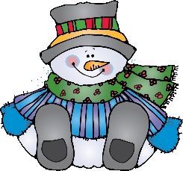 | 10  1 – 2:30pm  Book Club: Beloved by Toni Morrison | 11  10am-12pm  Knitting Club | 12
13 | 14  7 – 8:30 pm  Snowman Paver Doorstop with Pat Dahl | 15  10:30am – 12noon  Book Club: After You by Jojo Moyes’ | 16  7 – 8:30 pm  Board Meeting | 17  3 – 4 pm  TechConnect: Basic Computer Skills  7:30 – 8:30 pm  Adults: Mindfulness Meditation | 18 | 19  10 am – 12 noon  Beginner Knitters
20 | 21 CLOSED  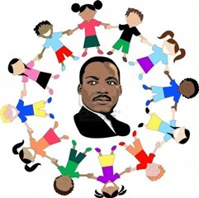 | 22 | 23  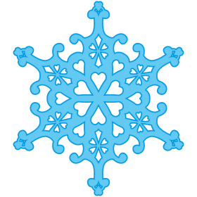 | 24 | 25  10am-12pm  Knitting Club  1 – 3 pm  Movie Matinee: The Post | 26
27 | 28 | 29 | 30 | 31 |  | 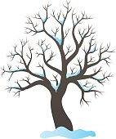

*Any programs that are red require prior online registration.

Adult Programs: Please visit https://northbrunswicklibrary.org/upcoming-events-for-adults/ to register.
*Programs in red require registration.
*Programs in blue are drop-in and do not require registration.

January Program Descriptions
All ages –Coloring Craze: Relax and color winter themed pages located in the children & teen areas. Colored pencils are available at the front desk. Registration not necessary.

All ages: Puzzlemania! Work on word searches, mazes, Sudoku, crossword puzzles and more or put together a jigsaw puzzle with others. Printed puzzle pages are located in the children & teen areas. Ask at the front desk for jigsaw puzzles. Registration not necessary.

Adults: Monday Evening Book Club: Meets monthly on the 1st Wednesday of the month. Registration not necessary.

Adults: Beginner Knitting Class: This class is for anyone who is new to knitting. Please bring your current project for help. Registration not necessary.

Adults: Painted Cactus Rocks with Barbara: Paint rocks to look like cacti. Register online

Adults: Drop-in Tech Help Short assistance for any tech questions a patron may have. No registration required. Sessions will be for 15 minutes per patron and held in the meeting room. Date and Time: Monthly on the 3rd Tuesday from 7:00 PM to 8:00 PM

Adults – Thursday Afternoon Book Club: Meets monthly on the 2nd Thursday of the month. Registration not necessary.

Adults: Knitting Club: Bring your current knitting project to the library and enjoy the company of others. This is NOT a knitting class although attendees are willing to help. Registration not necessary.

Adults: Snowman Paver Doorstop with Pat Dahl: Paint a cute snowman on a paver and use as a doorstop. Register online

Adults – Tuesday morning book club: Meets monthly on the 3rd Tuesday of the month. Registration not necessary.

Adults – TechConnect: Basic Computer Skills - A class on a specific technology topic. Each session will be different and have a predetermined topic. Classes will be held in the meeting room for one hour. Registration for each session is required. Interested patrons may sign up online, in person at the reference desk or over the phone. Signups will be held online or in the computer binder and be available one month prior to the session. There is a maximum of 6 people per class. Date and Time: Monthly on the 3rd Thursday of the month from 3:00 PM to 4:00 PM Registration Required.

Adults - Mindfulness Meditation: Meditation practice helps us to achieve mindfulness and reduce stress. All are welcome, including beginners and those who have been practicing for years. Several techniques will be introduced by instructor Dr. Siobhan Gibbons. Registration not necessary.

Adults: Movie Matinee: The Post: A cover-up that spanned four U.S. Presidents pushed the country's first female newspaper publisher and a hard-driving editor to join an unprecedented battle between the press and the government. Registration not necessary.

Any questions, please contact Barbara Elieff, Adult Services Librarian, North Brunswick Library, 732-246-3545 or nobrlibrarian@gmail.com

